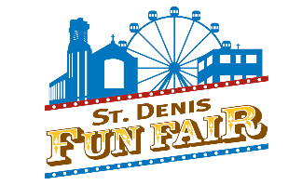
2021 Virtual St. Denis Fun Fair
Friday, April 30th to Thursday, May 6th

Funnel Cake & Water Ice Drive Thru
Friday, April 30th (5:30 to 9:30pm)
We are strictly following the Chester County Health Department for social distancing and mask wearing while on the campus of Cardinal John Foley School. We kindly ask you to comply with these measures.
Details on how to purchase will be posted soon (keep checking the St. Denis Fun Fair Facebook Page)

BINGO
Saturday, May 1st (4:00-6:00pm/approx.)
Play bingo with your St Denis Fun Fair friends virtually!
The winner of each game will receive a gift card from a local vendor. Links and cards will be provided via ZOOM*.

KAHOOT Trivia
Saturday, May 1st (7-9pm/approx.)
Compete with your St Denis Fun Fair friends virtually! General knowledge & Fun Fair trivia games. The winner of each game will receive a gift card from a local vendor. Get a head start and DOWNLOAD the Kahoot app on your phone or computer.
Game Pins will be announced in the 2021 Virtual Fun Fair ZOOM*.


Kentucky Derby
Saturday, May 1st (7:30pm approx./ after first round of Kahoot)
Purchase tickets BEFORE Kentucky Derby at 6:55pm by choosing winning horse.
Details on how to purchase will be posted soon (keep checking the St. Denis Fun Fair Facebook Page)
Tickets for the winning horse will be entered into a drawing for a new gas grill! ZOOM*.

50/50
Saturday, May 1st (6:30pm/ 8:00pm (approx.)
Purchase $2, $5 or $10 50/50 raffle tickets. The winner of each raffle will receive 50% of the total amount sold. ZOOM*.
Details on how to purchase will be posted soon (keep checking the St. Denis Fun Fair Facebook Page)

*ZOOM will be 4-9pm: Meeting ID: 484 450 8790 Passcode: 554885





Saturday, May 1st & Sunday, May 2nd ~ Wilson’s Secret Sauce ~ 484-453-8608
$1 donated back to Fun Fair for every sandwich purchase. Mention the St. Denis Fun Fair when ordering.
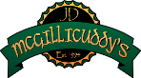
(Dine-In or Take-Out)

Sunday, May 2nd – Thursday, May 6th ~ JD McGillicuddy’s Brookline ~ 484-454-5289
10% donated back to Fun Fair on your food purchase. Mention the St. Denis Fun Fair when ordering.
(Dine-In or Take-Out)(not during Breakfast on Sunday)

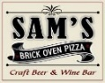
Wednesday, May 5th ~ Sam’s Brick Oven Pizza ~ 610-658-2626
10% donated back to Fun Fair on your food purchase. Mention the St. Denis Fun Fair when ordering.
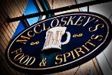
(Dine-In or Take-Out)(Reservations recommended)

Thursday, May 6th ~ McCloskey’s ~ 610-642-9280
10% donated back to Fun Fair on your food purchase (5-10pm). Mention the St. Denis Fun Fair when ordering.
Enjoy some LIVE MUSIC also!! Chico, Campo, & TMac performing 6-9pm at McCloskey’s!!
(Dine-In or Take-Out)(Reservations recommended)

(More details about Restaurant Week located on Facebook page- St.Denis Family Fun Fair)

